**Competitor Analysis**

**Identify three competitor/similar websites and complete the following work in a Microsoft Word or LibreOffice document.**

1. **Identify 3 competitors**
   * **What is the name of each competitor or their company/organization name?**
   * Coinbase
   * Binance
   * Poloniex
   * **What is the URL to each competitor’s website?**
   * <https://www.coinbase.com>
   * <https://www.binance.com/en>
   * <https://www.poloniex.com/exchange#btc_str>
   * **Explain whether each website is from a direct or indirect competitor? Write a 2-4 sentences explaining your logic for each website (total of 6-12 sentences)**
   * Coinbase is the direct competition with Binance and Poloniex in the Blockchain industry. All three sell and buy Cryptocurrency, which is the same product. All three trading platforms are also indirect, because they are competing for the same market. Although I chose to compare Coinbase, Binance, and Poloniex, there are other trading platforms too. For example, Bitmex, Bitbtc and Coinexchange.io are direct and indirect competition to the three that I chose. The platforms are all Blockchain companies that have been around for the past eight years or less.
   * **Include a screenshot of each home page**

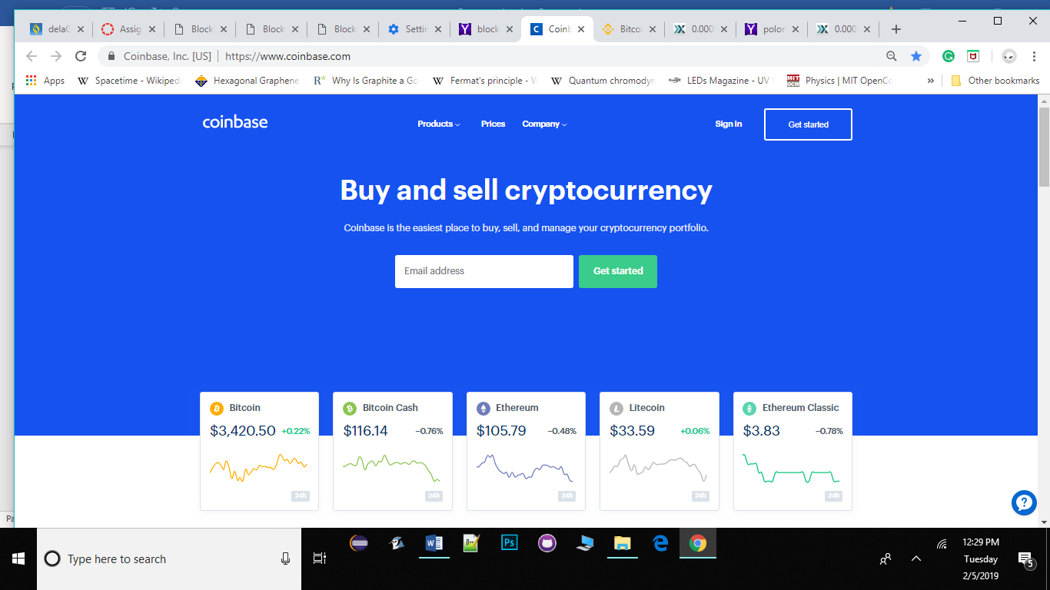

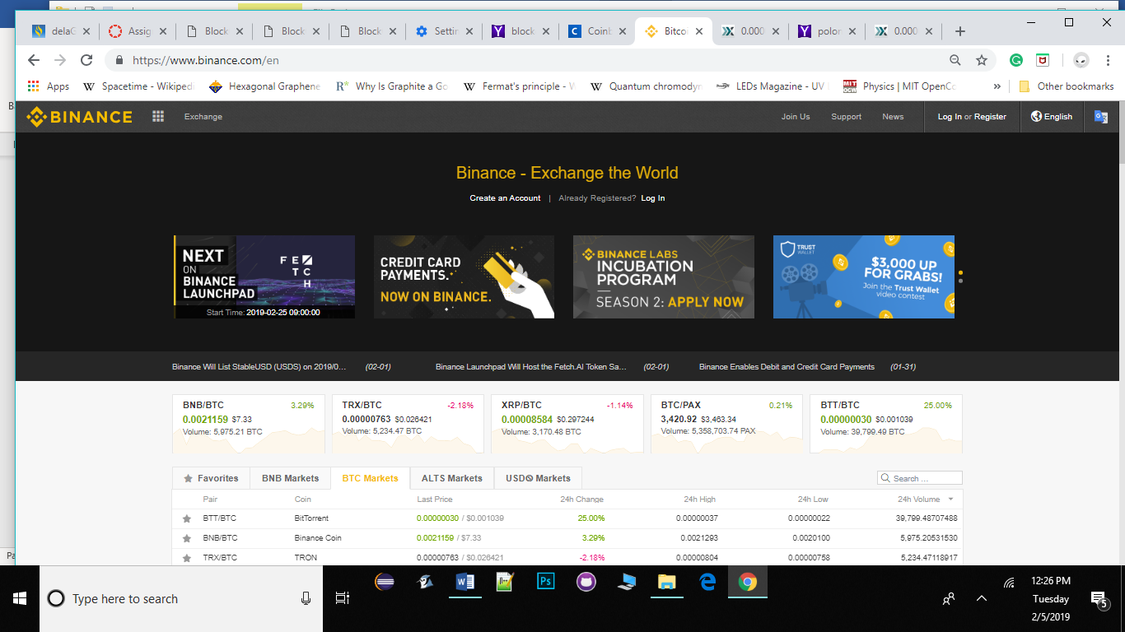

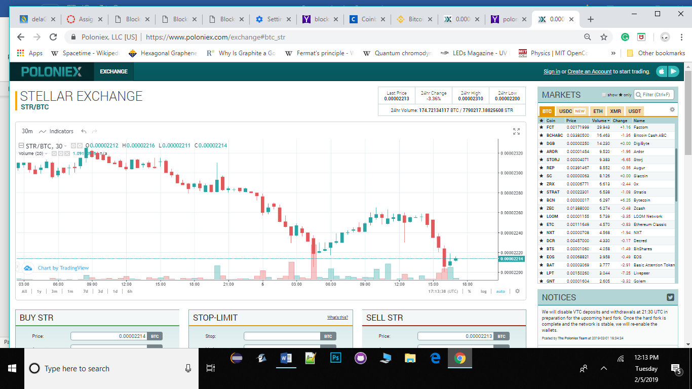

1. **Content and navigation.**

**Include a screenshot of each website’s menu and make sure to label each graphic with the name of the competitor (just the text of the name will do under the graphic).**

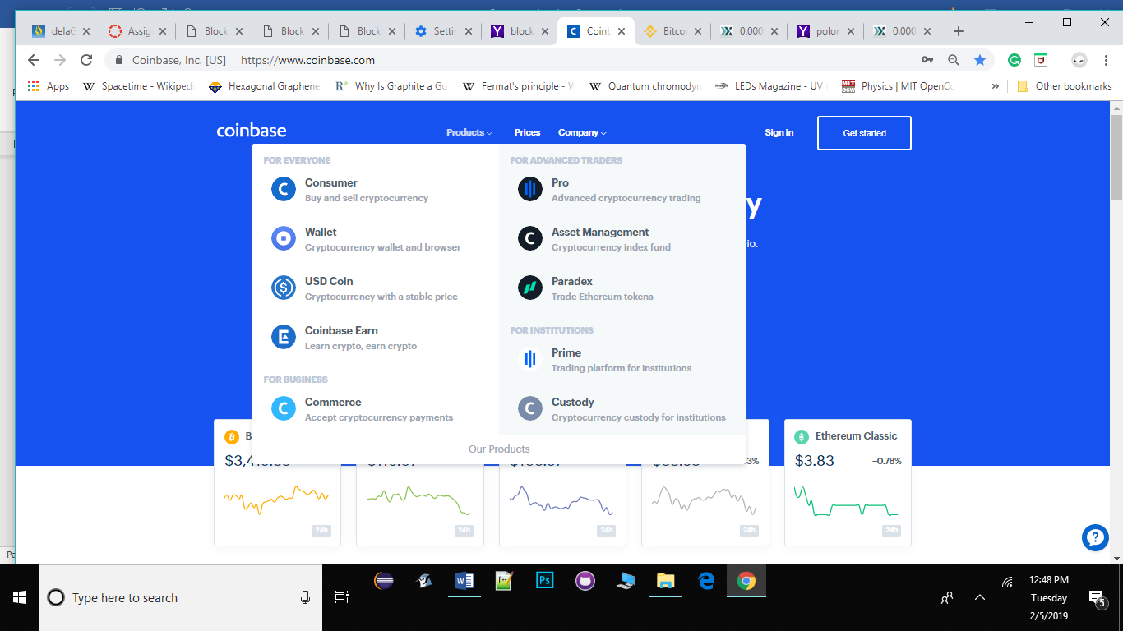**Coinbase**

**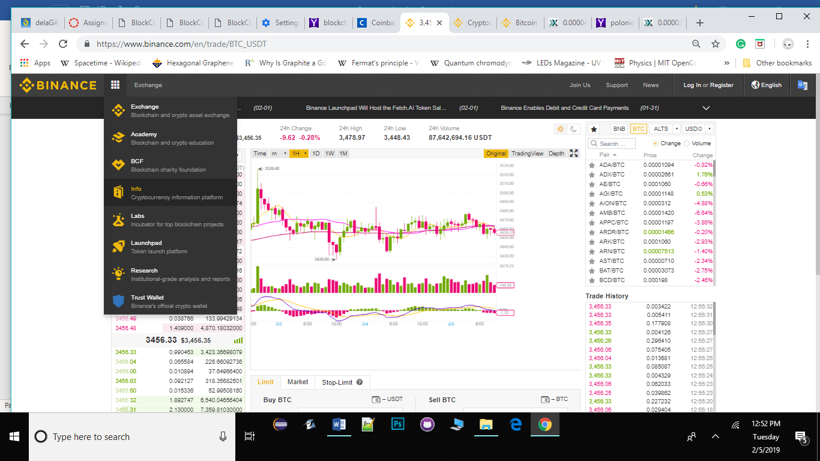  
Binance**

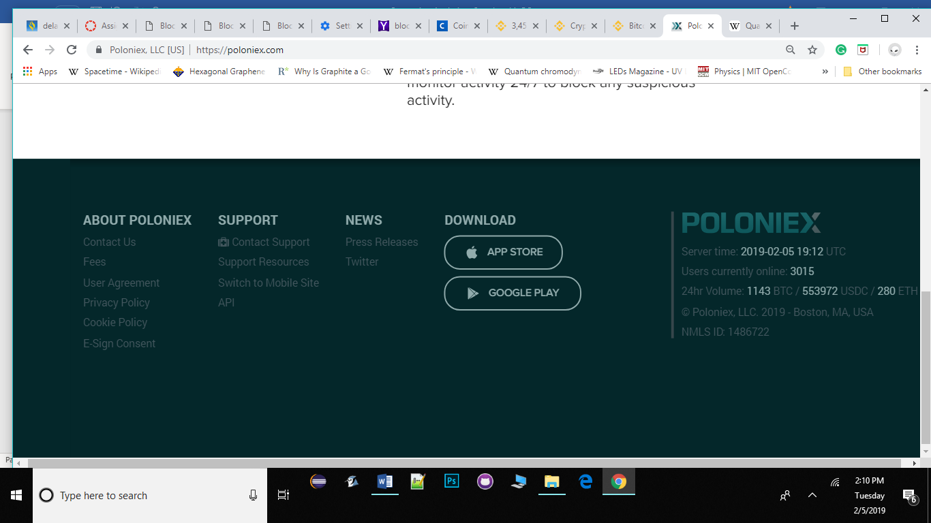**Poloniex**

* + **Explain how each of the 3 menus work. Write 3-5 sentences each (total of 9-15 sentences).** The3 menus have similarities and works almost the same way. **Coinbase** menu gives the customers the options For Everyone and For Advanced Traders. The menu also gives options that ranges from customer Wallets, Asset Management, and Institutional Custody. **Binance**‘smenu offers Blockchain and crypto asset exchange, crypto education, and Institutional-grade analysis and reports. **Poloniex**’smenu gives the news, support resources, fees info, and a few social media platforms info.
  + **Rank best menu to worst and explain your logic.** Thebest menu is Binance, which I rank at number 1. It gives the most accurate trading and useful information for customers. I rank coinbase at 2nd place. It’s menu is accessible and easy to use. I rank Poloniex at 3rd place. This menu does not give a lot to work with. The information, for customers, is hard to find and the website is hard to navigate.

1. **Aesthetics and style**
   * **Take screenshots of examples of color and imagery from each website. Crop out the parts you are focused on. For example, if a hot dog is your example, crop it out from the rest of the screenshot. Windows includes a tool called the Snipping Tool which lets you take a screenshot and select the part of your screen to select. Other operating systems should offer similar tools.**
   * **Discuss how color and imagery is used on each site. Write 2-3 sentences each (total of 6-9 sentences). Discuss if you think the color and imagery is used well, whether it reinforces their brand… etc.**



This image is from Binance. The color and imagery are used to market and attract customers to their Trust wallet. I think the color and imagery is used well, because blue symbolizes trust or loyalty, while yellow represents positivity or honor. Both colors work great with the Trust wallet while reinforcing their brand.

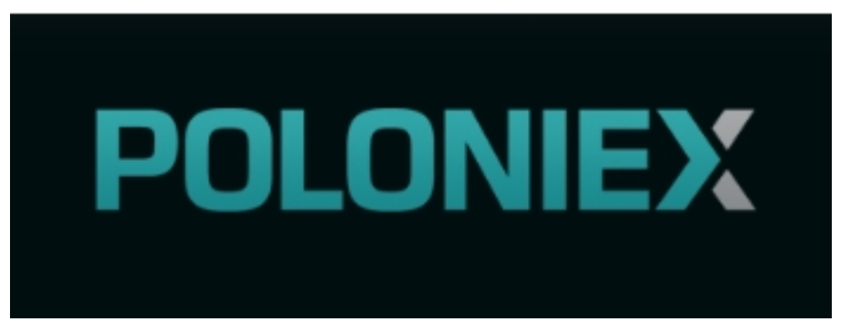

This image is from Poloniex. The color and imagery are used to market the company’s brand. The color and imagery are lacking interest, and therefore does not symbolized, represents or reinforcing their brand.

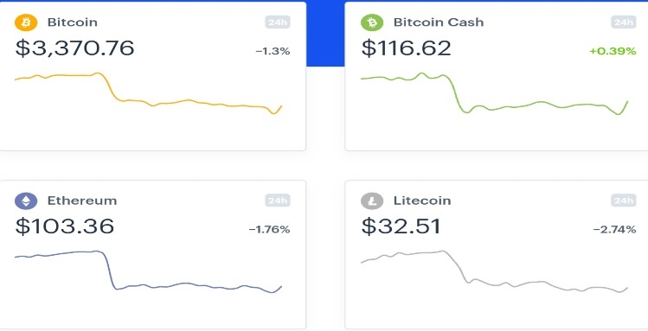

This image is from Coinbase. The color and imagery are used to market and attracts customers to a few of their flagship digital currencies. I think the color and imagery are used well, because the multiple colors on each digital currency represents the brand of the coin and the movement of the graphs. The colors work great and they are reinforcing the brand.

1. **Heuristic analysis**
   * **Select 3 of the heuristics from the above link (make sure to list the names). Compare and contrast your 3 competitors using those 3 heuristics. Write 2-4 sentences each (total of 8-12 sentences).**

The 3 heuristics that I will use are Visibility of system statues, Error prevention and Flexibility and efficiency of use, to compare and contrast the 3 competitors. When it comes to using binanace, the visibility of system statues has always work well in comparison to using coinbase or poloniex. Coinbase tends to have glitches as well as poloniex do but is 10 times slower. Binance responsiveness is quick, while taking into consideration the millions of people using the website at the same time around the world.

Binance and coinbase seems to have better error prevention than poloniex. From personal experiences with all 3 trading platforms, I’ve experienced more issues with poloniex and coinbase. Binance seems to have better rate of error prevention, which is likely due to the simplicity of the information on their platform.

The binance team seems to have better Software and Network engineers. The reasons being, the overall experience navigating the 3 websites, binance takes the cake. The flexibility and efficiency of use continues to manifest while using binance platform. I can’t say the same for coinbase and poloniex.

1. **UI animations**
   * **Explain how each site uses UI animation. Write 2-3 sentences each (total of 6-9 sentences.** Coinbase uses UI to highlight and market their flagship products, to draw attention to main areas. Binance uses UI animation the best, in similar ways as coinbase but with more emphasis on their products. Poloniex uses it on just a few unimportant areas. I’ve been trading on all 3 platforms for the past 2 years, so I have real experiences with them.
   * **Are the UI animations for each site valuable, fluff (just for looks) or somewhere in the middle?** I’ll revert to Binance and Coinbase, the UI animations for each site were valuable.Poloniex UI animation is just for looks and it had no substance.
   * **How do the competitors fare against each other with UI animation?** Coinbase and Binance are in competition for the UI animation spot. They are both well built websites with wonderful user interaction. Poloniex UI animation needs a lot of work.
2. **Score each website**
   * **Score each website for the 4 categories shown in the below table (UX for the Web page 48). Replace the example competitors and scores with your own. See UX for Web page 47 for how to come up with the scores. Total the categories to see how the competitors fare against each other overall. Feel free to copy and paste the below table into your document to make your life easier and replace the names and numbers.**

Coinbase Binance Poloniex

Content & 9 10 5

Navigation

Aesthetics & style 9 9 6

Heuristic Analysis 6 7 5

UI Animation 7 9 2

**7.5 9.1 5**